

Faculty of Computers and Artificial Intelligence
Cairo University
Third Year – Datawarehouse Project 2026
Dr. Ali Zedan

Nvidia Enterprise Operations Data Warehouse

Submitted by:

Name | IDs | Sections
Mohamed Walid | 20230585 | S2
Ibrahim Mohamed Saad | 20230003 | S2
Ezzeldin Omar Abd-Ellatif | 20230233 | S2
Ahmed Hussein Mohamed | 20230016 | S6
Ziad Sabry Mansour | 20230155 | S6

1.Key performance Indicators (KPIs)
The primary objective of this Data Warehouse is to extract actionable insights regarding sales performance, supply chain logistics, and internal departmental projects.
Key Performance Indicators (KPIs) Defined for Extraction:
- Total Revenue by Region and Product Category: To identify which geographic regions and hardware types (e.g., AI Accelerators vs. Gaming GPUs) drive the most profit.
- Total Sales Volume (Units Sold): To track the movement of physical inventory over time (monthly/quarterly).
- Revenue by Customer Industry: To understand which business sectors (e.g., Cloud Services, Data Centers, Research) are the most valuable clients.
- Supply Chain Volume by Vendor: To measure the total quantity of raw materials supplied by specific vendors to ensure supply chain stability.
- Departmental Project Budget Allocation: To monitor how much financial budget is allocated to internal R&D and operational projects.
- Average Project Duration: To measure the operational efficiency (in days) of projects from start date to end date across different departments.
- Departmental Salary Expenditure: To track the financial overhead of employee salaries grouped by department and location.

2. Physical Model of Source System
The source OLTP system is a normalized relational database consisting of 8 tables handling daily business transactions across HR, Sales, Supply Chain, and Project Management.
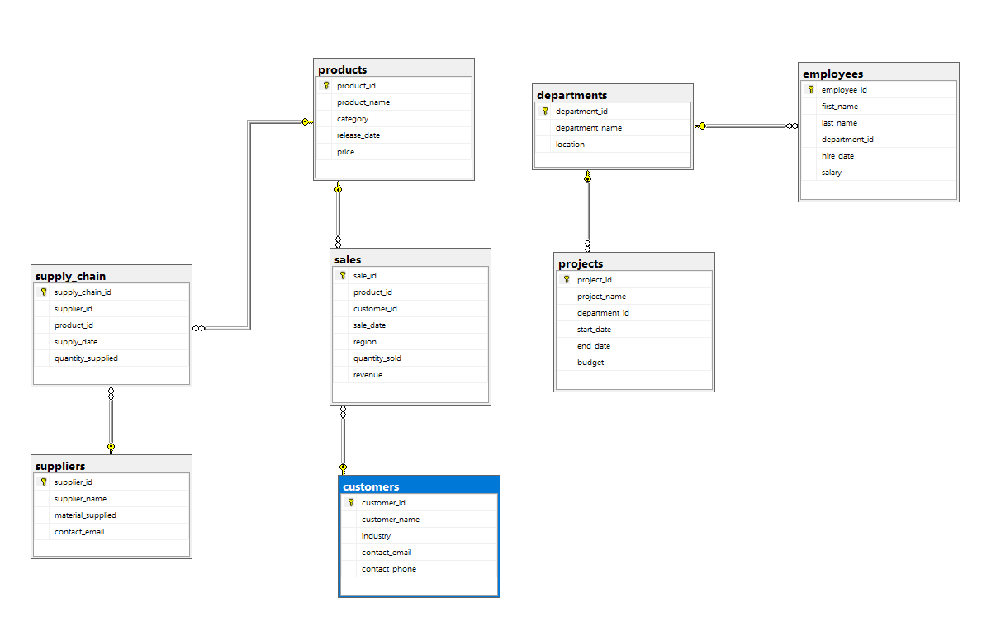Physical Model of the Nvidia OLTP Source System
Source System Data Dictionary & Relationships:
- customers
  - Columns: customer_id (PK), customer_name, industry, contact_email, contact_phone
  - Description: Stores client profile data.
- departments
  - Columns: department_id (PK), department_name, location
  - Description: Stores internal company divisions.
- employees
  - Columns: employee_id (PK), first_name, last_name, department_id (FK), hire_date, salary
  - Description: HR records, linked to departments.
- products
  - Columns: product_id (PK), product_name, category, release_date, price
  - Description: Catalog of hardware components sold.
- projects
  - Columns: project_id (PK), project_name, department_id (FK), start_date, end_date, budget
  - Description: Internal company initiatives, linked to departments.
- sales (Transactional Table)
  - Columns: sale_id (PK), product_id (FK), customer_id (FK), sale_date, region, quantity_sold, revenue
  - Description: Logs finalized product sales, linking customers and products.
- suppliers
  - Columns: supplier_id (PK), supplier_name, material_supplied, contact_email
  - Description: Details of external vendors providing raw materials.
- supply_chain (Transactional Table)
  - Columns: supply_chain_id (PK), supplier_id (FK), product_id (FK), supply_date, quantity_supplied
  - Description: Logs deliveries of materials, linking suppliers and products.

3. Dimensional Modeling
3.1. Business Processes
Three core business processes were identified from the Nvidia OLTP source system. Each process maps to one fact table in the data warehouse and answers a defined set of KPIs.
 | Business Process | Fact Table Type | Dimensions Used
1 | Sales Process  Captures every completed product sale — links customer, product, region, date, units sold, and revenue. The primary revenue-facing process.  Source: sales | Transaction Fact | DimDate, DimProduct, DimCustomer  KPIs 1, 2, 3
2 | Supply Chain Process  Tracks inbound raw material deliveries from external vendors. Each event records the supplier, the product fed, delivery date, and quantity delivered.  Source: supply_chain | Transaction Fact | DimDate, DimSupplier, DimProduct  KPI 4
3 | HR / Project Management Process  Monitors internal project lifecycles from initiation to completion and departmental salary expenditure. One row per project, updated as milestones complete.  Source: projects, employees, departments | Accumulating Snapshot | DimDate (×2), DimDepartment, DimEmployee  KPIs 5, 6, 7

3.2. Galaxy Schema Design
FACT TABLES (3)
Fact Table | Type | Grain | Conformed Dims
FactSales | Transaction | One sale transaction event | DimDate, DimProduct, DimCustomer
FactSupplyChain | Transaction | One supplier delivery event | DimDate, DimSupplier, DimProduct
FactProjectHR | Accumulating Snapshot | One project lifecycle record | DimDate (×2), DimDepartment, DimEmployee

DIMENSION TABLES (6)

Conformed Dimensions
DimDate and DimProduct appear in more than one fact table with identical definitions.
Dimension | SCD Type | Rationale | Used By
DimDate | SCD Type 1 | Date attributes are fixed; no history needed | FactSales, FactSupplyChain, FactProjectHR
DimProduct | SCD Type 1 | Overwrite price/category on change; point-in-time price in fact row | FactSales, FactSupplyChain
DimCustomer | SCD Type 1 | Contact and industry overwrite acceptable | FactSales
DimSupplier | SCD Type 2 | Track supplier contract/material changes historically | FactSupplyChain
DimDepartment | SCD Type 2 | Track relocations and renames; preserve historical project linkage | FactProjectHR
DimEmployee | SCD Type 1 | Current salary in dimension; salary history via fact snapshots | FactProjectHR

3.3. Fact Table Declarations
Each fact table is defined with its grain, type, all foreign keys (with dimension targets), degenerate dimensions, and measures with additivity classifications.

FactSales
Grain
One row = one individual sale transaction. Each row represents a single customer purchasing a single product on a specific date in a specific region.
Type: Transaction Fact Table — atomic events; rows appended only, never updated.
Column | Key Type | Data Type | Notes
sale_sk | Surrogate PK | INT | DWH-generated key
date_sk | FK → DimDate | INT | Date of sale
product_sk | FK → DimProduct | INT | Product sold
customer_sk | FK → DimCustomer | INT | Purchasing customer
region | Degenerate Dim | VARCHAR(50) | No separate dim needed
sale_id | Source NK | INT | Original source key (audit)
quantity_sold | Measure | INT | Additive
revenue | Measure | DECIMAL(18,2) | Additive
unit_price | Measure | DECIMAL(18,2) | Non-additive

FactSupplyChain
Grain
One row = one supplier delivery event. Each row represents a single vendor delivering material for a specific product on a given date.
Type: Transaction Fact Table — immutable delivery events appended per shipment.
Column | Key Type | Data Type | Notes
supply_chain_sk | Surrogate PK | INT | DWH-generated key
date_sk | FK → DimDate | INT | Date of delivery
supplier_sk | FK → DimSupplier | INT | Delivering supplier
product_sk | FK → DimProduct | INT | Product fed by materials
supply_chain_id | Source NK | INT | Original source key (audit)
quantity_supplied | Measure | INT | Additive
FactProjectHR
Grain
One row = one internal project, tracked across its lifecycle. DimDate is role-played twice as start_date and end_date. Also captures departmental salary overhead at snapshot time.
Type: Accumulating Snapshot Fact Table — one row per project, created at initiation; date FKs and computed fields updated as milestones complete.
Column | Key Type | Data Type | Notes
project_sk | Surrogate PK | INT | DWH-generated key
start_date_sk | FK → DimDate | INT | Project start (role-playing)
end_date_sk | FK → DimDate | INT | Project end (role-playing, NULL until complete)
department_sk | FK → DimDepartment | INT | Owning department
employee_sk | FK → DimEmployee | INT | Project lead / responsible employee
project_id | Source NK | INT | Original source key (audit)
project_budget | Measure | DECIMAL(18,2) | Additive
duration_days | Measure | INT | Semi-additive
dept_salary_expenditure | Measure | DECIMAL(18,2) | Semi-additive

3.4. Dimension Table Declarations
All six-dimension tables are documented with surrogate keys, natural keys, SCD type and per-field SCD treatment, data types, and descriptive notes.

DimDate
Type: SCD Type 1 — Overwrite | Date attributes are static facts; no historical tracking required.
Column | Key Type | Data Type | SCD Rule | Description
date_sk | Surrogate PK | INT | Identity | DWH-generated surrogate key
full_date | Natural Key | DATE | Overwrite | Calendar date (YYYY-MM-DD)
day_of_week | Attribute | TINYINT | Overwrite | 1=Monday … 7=Sunday
day_of_month | Attribute | TINYINT | Overwrite | 1–31
month_number | Attribute | TINYINT | Overwrite | 1–12
month_name | Attribute | VARCHAR(12) | Overwrite | January … December
quarter | Attribute | TINYINT | Overwrite | 1–4
year | Attribute | SMALLINT | Overwrite | Four-digit year
is_weekend | Attribute | BIT | Overwrite | 1 if Saturday or Sunday

DimProduct
Type: SCD Type 1 — Overwrite | Price and category changes overwrite; point-in-time price captured in FactSales.
Column | Key Type | Data Type | SCD Rule | Description
product_sk | Surrogate PK | INT | Identity | DWH-generated surrogate key
product_id | Natural Key | INT | Lookup | Source system product_id
product_name | Attribute | VARCHAR(200) | Overwrite | Full product name
category | Attribute | VARCHAR(100) | Overwrite | e.g. AI Accelerator, Gaming GPU
release_date | Attribute | DATE | Overwrite | Original product release date
current_price | Attribute | DECIMAL(18,2) | Overwrite | Current list price

DimCustomer
Type: SCD Type 1 — Overwrite | Contact details and industry classification overwritten on change.
Column | Key Type | Data Type | SCD Rule | Description
customer_sk | Surrogate PK | INT | Identity | DWH-generated surrogate key
customer_id | Natural Key | INT | Lookup | Source system customer_id
customer_name | Attribute | VARCHAR(200) | Overwrite | Legal customer name
industry | Attribute | VARCHAR(100) | Overwrite | e.g. Cloud Services, Data Centers
contact_email | Attribute | VARCHAR(200) | Overwrite | Primary contact email
contact_phone | Attribute | VARCHAR(30) | Overwrite | Primary contact phone

DimSupplier
Type: SCD Type 2 — Insert new row on change | Full history of supplier contract/material changes preserved via versioned rows.
Column | Key Type | Data Type | SCD Rule | Description
supplier_sk | Surrogate PK | INT | Identity | DWH-generated surrogate key (new row = new key)
supplier_id | Natural Key | INT | Lookup | Source system supplier_id (stable across versions)
supplier_name | Attribute | VARCHAR(200) | Versioned | Supplier name at time of version
material_supplied | Attribute | VARCHAR(200) | Versioned | Materials supplied at time of version
contact_email | Attribute | VARCHAR(200) | Overwrite | Current contact (not versioned)
effective_date | Attribute | DATE | SCD-2 metadata | Start date of this version
expiry_date | Attribute | DATE | SCD-2 metadata | End date of this version (NULL = current)
is_current | Attribute | BIT | SCD-2 metadata | 1 = active version

DimDepartment
Type: SCD Type 2 — Insert new row on change | Track relocations and renames; preserves historical project-to-department associations.
Column | Key Type | Data Type | SCD Rule | Description
department_sk | Surrogate PK | INT | Identity | DWH-generated surrogate key (new row = new key)
department_id | Natural Key | INT | Lookup | Source system department_id
department_name | Attribute | VARCHAR(200) | Versioned | Department name at time of version
location | Attribute | VARCHAR(200) | Versioned | Physical location at time of version
effective_date | Attribute | DATE | SCD-2 metadata | Start date of this version
expiry_date | Attribute | DATE | SCD-2 metadata | End date of this version (NULL = current)
is_current | Attribute | BIT | SCD-2 metadata | 1 = active version

DimEmployee
Type: SCD Type 1 — Overwrite | Current salary in dimension; historical salary changes captured via FactProjectHR snapshots.
Column | Key Type | Data Type | SCD Rule | Description
employee_sk | Surrogate PK | INT | Identity | DWH-generated surrogate key
employee_id | Natural Key | INT | Lookup | Source system employee_id
first_name | Attribute | VARCHAR(100) | Overwrite | Employee first name
last_name | Attribute | VARCHAR(100) | Overwrite | Employee last name
department_sk | FK → DimDepartment | INT | Overwrite | Current department assignment
hire_date | Attribute | DATE | Overwrite | Original hire date
current_salary | Attribute | DECIMAL(18,2) | Overwrite | Current salary (overwritten on raise)

3.5. Measure Declarations
All 7 measures across the 3 fact tables are declared with data types, additivity classifications, and KPI mappings. Additivity determines which SQL aggregation functions are valid.
ADDITIVITY REFERENCE
Additive | Can be summed across ALL dimensions (time, geography, product, customer). Most useful for BI aggregations.
Semi-additive | Can be summed across SOME dimensions (e.g. across departments) but NOT across time. Use AVG or point-in-time snapshots for time-based analysis.
Non-additive | CANNOT be summed across any dimension. Must use non-additive functions: AVG, MIN, MAX, or point-in-time lookup only.

ALL MEASURES
Measure | Fact Table | Data Type | Additivity | KPI / Notes
quantity_sold | FactSales | INT | Additive | KPI 2 — sum across region/product/date
revenue | FactSales | DECIMAL(18,2) | Additive | KPI 1, 3 — sum by region, category, industry
unit_price | FactSales | DECIMAL(18,2) | Non-additive | Use AVG; summing is meaningless
quantity_supplied | FactSupplyChain | INT | Additive | KPI 4 — total volume by supplier/product
project_budget | FactProjectHR | DECIMAL(18,2) | Additive | KPI 5 — sum across projects/departments
duration_days | FactProjectHR | INT | Semi-additive | KPI 6 — AVG across projects; do not sum across time
dept_salary_expenditure | FactProjectHR | DECIMAL(18,2) | Semi-additive | KPI 7 — sum across departments; do not sum across periods

3.6. Physical Model — Galaxy Schema
The physical data warehouse model is a Galaxy (Fact Constellation) schema. All fact-to-dimension relationships are N:1 (many fact rows to one dimension row). DimDate and DimProduct are conformed dimensions appearing in multiple fact tables.

SCHEMA LAYOUT — ALL 9 TABLES
Table | Columns (SK | NK | Measures/Attributes)
FactSales | sale_sk (PK) | — | date_sk, product_sk, customer_sk (FKs) | region (DD) | quantity_sold, revenue, unit_price
FactSupplyChain | supply_chain_sk (PK) | — | date_sk, supplier_sk, product_sk (FKs) | quantity_supplied
FactProjectHR | project_sk (PK) | — | start_date_sk, end_date_sk, department_sk, employee_sk (FKs) | project_budget, duration_days, dept_salary_expenditure
DimDate | date_sk (PK) | full_date (NK) | day_of_week, day_of_month, month_number, month_name, quarter, year, is_weekend
DimProduct | product_sk (PK) | product_id (NK) | product_name, category, release_date, current_price
DimCustomer | customer_sk (PK) | customer_id (NK) | customer_name, industry, contact_email, contact_phone
DimSupplier | supplier_sk (PK) | supplier_id (NK) | supplier_name, material_supplied, contact_email | effective_date, expiry_date, is_current
DimDepartment | department_sk (PK) | department_id (NK) | department_name, location | effective_date, expiry_date, is_current
DimEmployee | employee_sk (PK) | employee_id (NK) | first_name, last_name, department_sk (FK), hire_date, current_salary

ALL FOREIGN KEY RELATIONSHIPS (11 TOTAL)
Foreign Key (Fact/Dim) | References (PK) | Card. | Dimension | Relationship Note
FactSales.date_sk | DimDate.date_sk | N:1 | DimDate | Sale date lookup
FactSales.product_sk | DimProduct.product_sk | N:1 | DimProduct | Product sold
FactSales.customer_sk | DimCustomer.customer_sk | N:1 | DimCustomer | Purchasing customer
FactSupplyChain.date_sk | DimDate.date_sk | N:1 | DimDate | Delivery date lookup (conformed)
FactSupplyChain.supplier_sk | DimSupplier.supplier_sk | N:1 | DimSupplier | Delivering supplier
FactSupplyChain.product_sk | DimProduct.product_sk | N:1 | DimProduct | Product fed (conformed)
FactProjectHR.start_date_sk | DimDate.date_sk | N:1 | DimDate | Project start (role-playing)
FactProjectHR.end_date_sk | DimDate.date_sk | N:1 | DimDate | Project end (role-playing)
FactProjectHR.department_sk | DimDepartment.department_sk | N:1 | DimDepartment | Owning department
FactProjectHR.employee_sk | DimEmployee.employee_sk | N:1 | DimEmployee | Project lead
DimEmployee.department_sk | DimDepartment.department_sk | N:1 | DimDepartment | Employee dept assignment

Role-Playing Dimension
DimDate is role-played twice in FactProjectHR — once as start_date_sk and once as end_date_sk. Both FKs point to the same DimDate table. In SQL queries, two aliases are used: e.g. JOIN DimDate AS StartDate ON FactProjectHR.start_date_sk = StartDate.date_sk and JOIN DimDate AS EndDate ON FactProjectHR.end_date_sk = EndDate.date_sk.

